Liquid heater specification(8kw)

2020

CATALOG
1. Product introduction
1.1 Product overview
1.1.1 Function
1.1.2 Features
1.2 Product appearance
1.3 Product size
1.4 Product connector and interface definition
1.5 Product exploded view
2. Basic electrical performance of the product
2.1 Basic electrical parameters
2.2 Temperature
2.3 Low pressure
2.4 High pressure
2.5 High voltage safety
3. Product control plan
3.1 Air conditioning control framework
3.2 Block diagram of control principle
3.3 Control method
3.4 Control function
3.4.1 Soft start function: PWM soft start
3.4.2 Restricted functions:
3.4.3 Protection function:
4. Precautions for product installation
5. Precautions for the use of PTC water heating heater
6. Common fault diagnosis, inspection and maintenance of PTC plumbing heater
1. Product introduction
1.1 Product overview
1.1.1 Function
PTC water heating heater can provide heat for the new energy vehicle cockpit and meet the standards of safe defrosting and defogging. At the same time, it provides heat to other vehicles that require temperature adjustment (such as batteries).
1.1.2 Features
Electricity is used to heat the antifreeze, and the heater is used to heat the interior of the car. Installed in the water cooling circulation system
Warm air and temperature controllable
Use PWM to adjust the drive IGBT to adjust the power with short-term heat storage function
Whole vehicle cycle, supporting battery thermal management and environmental protection

1.1.2 Product appearance

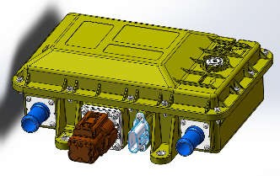

1.1.3 Product size

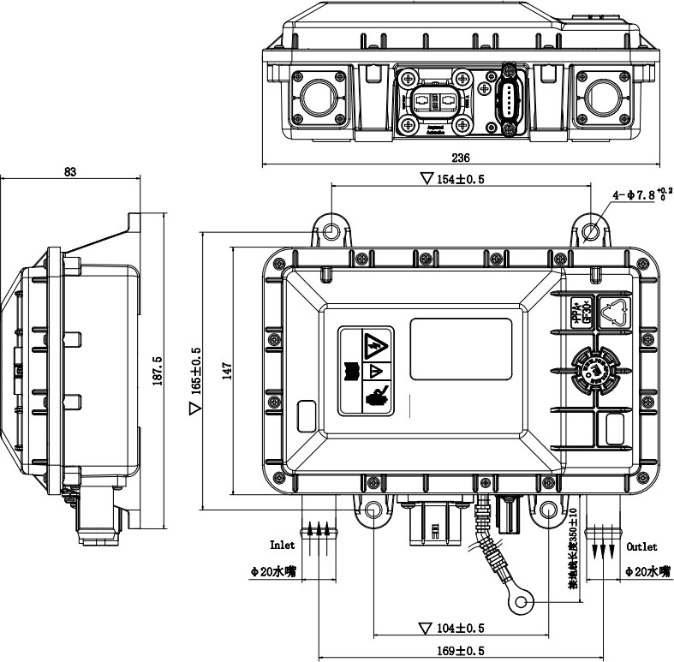

1.1.4 Product connector and interface definition

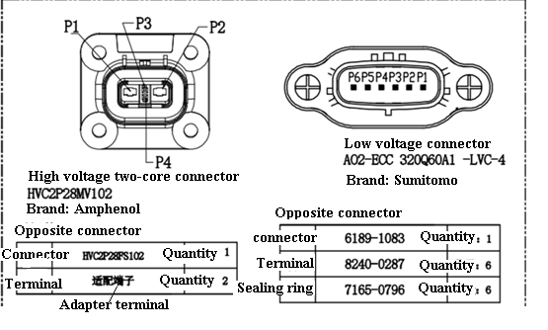
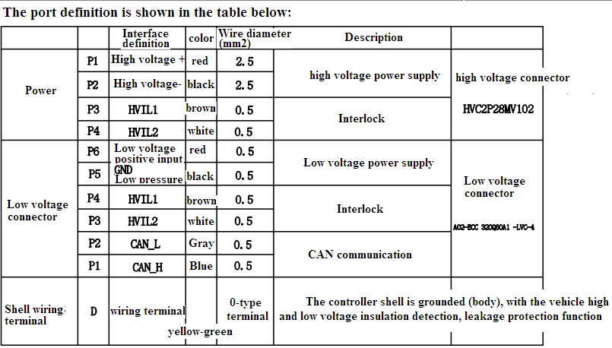

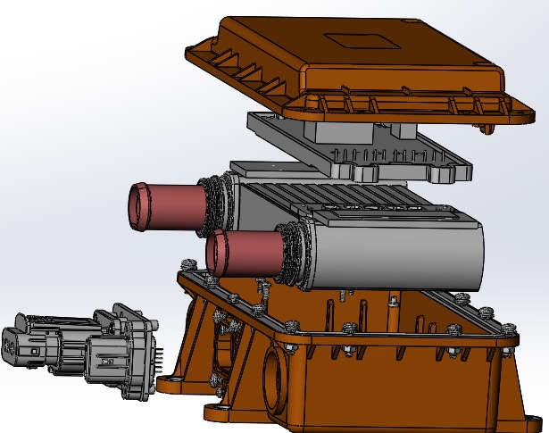1.1.5 Product exploded view
1.Upper base
7.High voltage
connector
2.Controller
panel
3.Heating core
assembly
4. Water tank
5.Gasket
6.Lower base
8.Low voltage connector
9.Nozzle seal

According to the voltage requirement of 600V, the PTC sheet is 3.5mm thick and TC210 ℃, which ensures good withstand voltage and durability. The internal heating core of the product is divided into four groups, which are controlled by four IGBTs. In order to ensure the protection grade of the product IP67, insert the heating core assembly into the lower base obliquely, cover the (Serial No. 9) nozzle sealing ring, and then press the outer part with the pressing plate, and then put it on the lower base (No. 6) is sealed with pouring glue and sealed to the upper surface of D-type pipe. After assembling other parts, the sealing gasket (No. 5) is used between the upper and lower bases to ensure the good waterproof performance of the product.
2. Basic electrical performance of the product
2.1 Basic electrical parameters

Description | Condition | Minimum | typical | maximum | unit
power | a) Test voltage: control voltage: DC24V; load voltage: 600VDC b) ambient temperature: 20℃±2℃; water inlet temperature: 0℃±2℃; flow rate: 10L/min  c) Air pressure: 70kPa~106ka  No coolant, no connecting wire |  | 8000 |  | W
weight | No coolant, no connecting wire |  | 2.7 |  | KG
Antifreeze volume |  |  | 170 |  | mL

  - Temperature

Description | Condition | Minimum | typical | maximum | unit
Storage temperature |  | -40 |  | 105 | ℃
Working temperature |  | -40 |  | 105 | ℃
environment humidity |  | 5% |  | 95% | RH

  - Low pressure

Description | Condition | Minimum | typical | maximum | unit
Control voltage VCC |  | 18 | 24 | 32 | V
Ground |  |  | 0 |  | V
Supply current | Steady state current | 90 | 120 | 160 | mA
Starting current |  |  |  | 1 | A
  - High pressure

Description | Condition | Minimum | typical | maximum | unit
Supply voltage | Turn on heating | 480 | 600 | 720 | V
Supply current | Nominal condition |  | 13.3 |  | A
Inrush current | Nominal condition |  |  | 17.3 | A
stand-by current | Nominal condition |  |  | 1.6 | mA
  - High voltage safety

1 | High voltage warning label | have
2 | Flame-retardant plastic insulation shell protection to prevent access to high-voltage live parts | have
3 | Basic insulation of high voltage live parts | have
4 | Provide potential equalization grounding point | have
5 | Insulation resistance>50MÙ | have
6 | Passive discharge | have
7 | High voltage interlock | have
8 | High voltage terminals comply with IPXXB protection | have
9 | Meets IP67 protection | have
10 | Comply with 2U+1000V withstand voltage test | have
11 | High pressure and overpressure turn off heating | have
12 | PTC over temperature protection | have
13 | PCB over temperature protection | have
14 | IGBT over temperature protection | have
15 | PTC overcurrent protection | have
16 | PTC short circuit protection | have
17 | IGBT breakdown feedback | have
18 | PTC temperature sensor failure detection, no heating when failure | have
19 | IGBT temperature sensor failure detection, no heating when failure | have
20 | PCB temperature sensor failure detection, no heating when failure | have
21 | Even if the IGBT control fails, the heater temperature does not exceed 200+℃ due to PTC's own characteristics | have
22 | Low voltage anti-reverse connection | have
23 | High voltage reverse connection feedback (reverse connection will cause uncontrolled heating and cause PTC damage) | have
24 | Controller power on and self-check, no heating if there is a fault | have
25 | Communication is interrupted and heating is stopped | have
26 | High voltage acquisition real-time feedback | have

Product control scheme
  - Air conditioning control framework

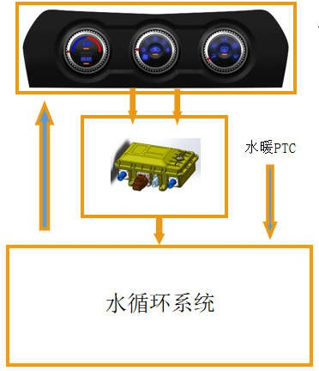
Plumbing PTC
water circulatory system

①The command input is completed by the air conditioner panel.
②The air conditioner panel sends the user's operation commands to the controller through CAN communication or ON/OFF PWM.
③After receiving the command signal, the plumbing PTC controller turns on the PTC in PWM mode according to the power requirements.
Design advantages:
①It adopts 4-channel PWM control mode, the bus impulse current is small, and the requirement for the relay in the whole vehicle loop is low.
②PWM mode control enables continuous power adjustment.
③The CAN communication mode can report the working status of the controller, which is convenient for the control and monitoring of the whole vehicle.

  - Block diagram of control principle

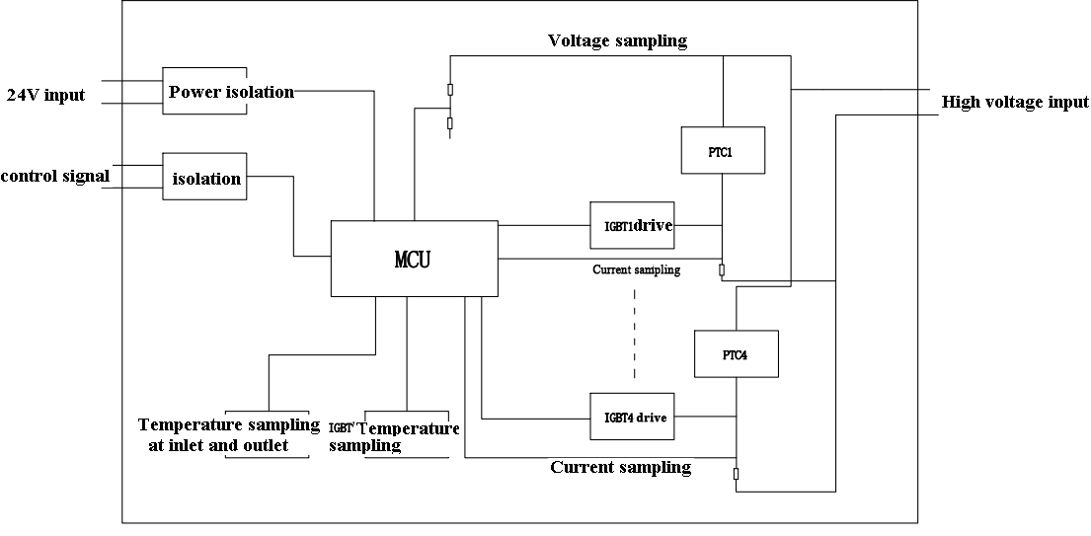

3.4 Control mode CAN communication
3.5 Control function
3.5.1 Soft start function: PWM soft start
PWM uses 30 seconds from 0% to 100%. This function is used to protect the high inrush current and sudden changes on the high voltage bus. Each channel is gradually soft-started, and there is ripple current during the soft-start process, and the inrush current is small (<1.3 times of the rated current).
3.5.2 Restricted function:
3.5.2.1 Temperature limit
①When the temperature of the water outlet reaches 80℃, the power will be gradually reduced to keep the temperature of the water outlet relatively constant
② When the temperature of any one of the IGBTs reaches 85°C, it will take the initiative to gradually reduce the power or shut down, and resume operation when it is lower than 80°C so that the IGBT temperature does not exceed the limit
3.3.1.1 Power limit
①Soft start power limit: The power of each channel is limited to 3800W during soft start
3.3.2 Protection function:
3.3.2.1 High-voltage over-voltage protection
The operating voltage range can be set according to customer requirements. The heaters that are not within the range will not start or shut down, and will be soft-started to the current set value after returning to the range.
3.3.2.2 IGBT drive voltage overvoltage protection
When the IGBT drive voltage is not within the set working range, the heating will be all shut down, and the soft start will be restarted to the current set value after recovery.
3.3.2.3 Low voltage reverse connection protection Low voltage reverse connection does not work.
3.3.2.4 Outlet water temperature over-temperature protection
When the water outlet temperature exceeds 105℃ for 3 seconds, all heating will be turned off immediately
3.3.2.5 Short circuit protection
If any PTC circuit is short-circuited, the circuit will be closed immediately, and the test will be repeated 5 times, but the circuit is still short-circuited, and the circuit will not be heated until it is powered on again.
3.3.2.6 Overcurrent protection
If the circuit exceeds 2 times the rated current for 5s during heating operation, it is considered as overloaded and the circuit is
Will be shut down and restarted.

Warning: High voltage does not have the ability to prevent reverse connection. High voltage reverse connection will cause direct heating to be uncontrolled. High voltage reverse connection may cause PTC damage, may cause the vehicle to fail to be precharged and fail to start, and may cause the precharge resistor to burn!

Precautions for product installation

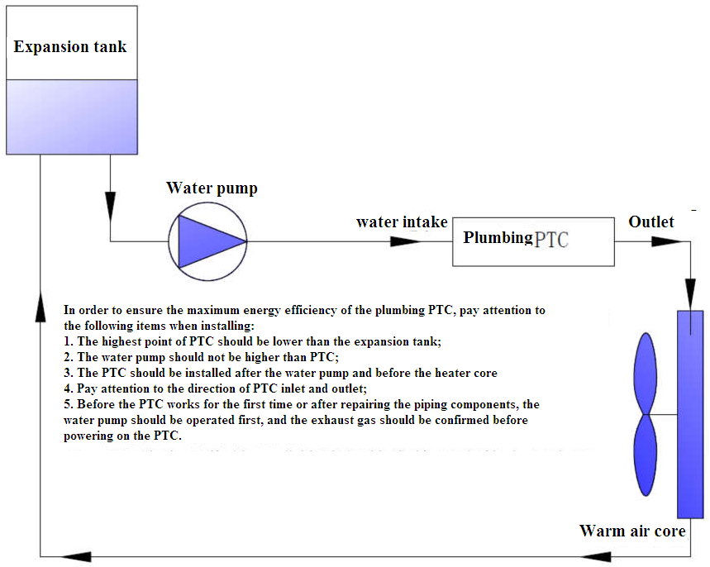

4.2 Before turning on the power, pay attention to the installation and the reliable connection of the connectors (the main high voltage cannot be reversed, otherwise the control will fail, and the control board will be damaged for more than 1 minute)
4.3 The ground wire is connected reliably to prevent static electricity from damaging the components
4.4 Antifreeze should not contain impurities to prevent blocking the water tank
4.5 After unpacking, please be sure to check whether there is any appearance damage caused by transportation. Damage caused by improper installation and use (including use and installation conditions outside the scope of the specification) is not covered by the warranty.
4.6 Product installation direction: The heater can be installed in other directions except that the water inlet and outlet cannot be downward at the same time.

5 Precautions for the use of PTC plumbing heater
5.2 After the heater is connected correctly, it is recommended to turn on low-voltage power and then high-voltage when powering on; when power-off, turn off high-voltage power and then low-voltage power.
5.3 The water flow rate in the water cycle is ≥4L/min. If the flow rate is too low, it will cause frequent temperature protection.

6 Common fault diagnosis, inspection and maintenance of PTC plumbing heater

Failure phenomenon | Cause of failure | Corrective measures
Can not be used | The high-voltage plug-in is not inserted or has poor contact | Check whether the high-voltage connector is in good contact
Can not be used | Low-voltage plug-in is not inserted or has poor contact | Check whether the low voltage connector is in good contact
Can not be used | Insulation resistance decreased | Replace PTC plumbing heater
No heating | High-voltage plug-in is damaged or poor contact | Check whether the high-voltage connector is in good contact
No heating | Low-voltage plug-in is damaged or poor contact | Check whether the low voltage connector is in good contact
No heating | Low voltage plug-in wiring sequence error | Check the wiring sequence of the low voltage connector
No heating | The PWM signal is not within the scope of the agreement | Adjust the PWM duty cycle within the adjustment range
No heating | PWM signal wire is shorted to ground | Check whether the signal terminal pins of the low-voltage connector are skewed and short-circuited,
No heating | PWM signal wire is shorted to power supply | Check whether the signal terminal pin of the low-voltage connector is skewed and short-circuited
No heating | Low pressure is not in range | Check voltage
No heating | High pressure is not in range | Check voltage

 | Internal sensor failure | Replace PTC plumbing heater
 | Internal control circuit failure | Replace PTC plumbing heater
Slow heating | Low water temperature slow start | no
Slow heating | Low PWM power request | Adjust the PWM duty cycle
Slow heating | Low high voltage voltage slow start | Adjust voltage
Slow heating | Low antifreeze flow | Adjust flow
Slow heating | Waterway is blocked | Cleaning the waterway
Slow heating | Partial failure of internal control circuit | Replace PTC plumbing heater
Direct heating without control signal | High voltage reverse connection | High voltage polarity can be changed within 1 minute
Direct heating without control signal | Internal control circuit failure | Replace PTC plumbing heater
Automatic shutdown and restart | Overcurrent | no
Automatic shutdown and restart | Over temperature | Reduce request power or increase traffic
Automatic shutdown and restart | PWM is sometimes out of range | Adjust the PWM duty cycle
Automatic shutdown and restart | Low pressure overpressure | Adjust voltage
Automatic shutdown and restart | Low pressure | Adjust voltage
Automatic shutdown and restart | High pressure overpressure | Adjust voltage
Automatic shutdown and restart | High pressure and undervoltage | Adjust voltage
Automatic shutdown and restart | Internal control circuit failure | Replace PTC liquid heater
External fuse blown | The heating core is short-circuited and the control circuit protection fails | Replace PTC liquid heater
External fuse blown | The high voltage positive and negative poles are short-circuited to the shell at the same t | Replace PTC liquid heater

